|  |  |  |  |
| --- | --- | --- | --- |
|  | |  |  | | --- | --- | |  | **Eastern Goldfields College**  ***Year 12 MATHEMATICS METHODS***  ***TEST 6 2016***  ***Calculator Free*** |   **Name:** |

**Total Marks: 11**

**Reading: 1 minute Time Allowed: 11 minutes**

1.

**[1, 3, 2, 2, 3 = 11 marks]**

A sample of 900 people found that 180 were able to twitch their nose without moving any other face muscles.

a) What is the sample proportion ($\hat{p}$) for people able to twitch their nose?

b) If we were to take many such samples, what would you expect the standard deviation of the sample proportions to equal?

c) Describe the distribution of sample proportions for sample size 900.

d) Given that 95.5% of the scores are within 2 standard deviations from the mean, what would be the 95.5% confidence interval for the sample proportion of people who could twitch their nose?

e) Using this sample proportion, if you randomly selected 3 people, what is the probability that exactly 2 could twitch their nose?

|  |  |  |  |
| --- | --- | --- | --- |
|  | |  |  | | --- | --- | |  | **Eastern Goldfields College**  **Year 12 MATHEMATICS METHODS**  **TEST 6 2016**  **Resource Rich**  **Total Marks: 24**  **Reading: 2 minutes Time Allowed: 26 minutes** |   **Name:** |

**2. (2, 2, 3 – 7 marks)**

A random variable that can only take the values of 0 or 1 is modelled by a Bernoulli distribution such that *P*(1) = 0.65

1. Three random samples were taken from this distribution. One sample was of size 25, one of size 100 and the other of size 500. The following three relative frequency graphs each show the distribution of one of the random samples.

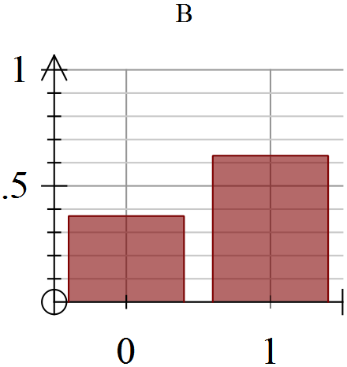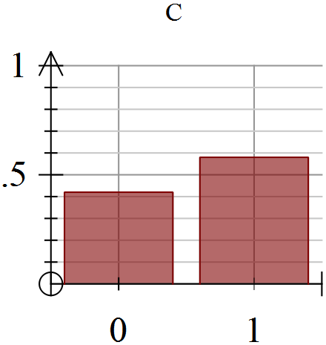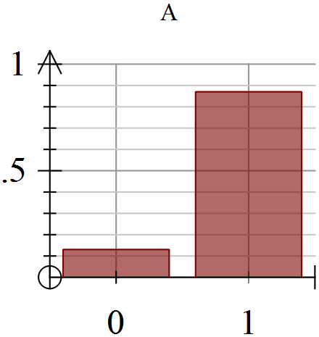

1. State, with reasons, the letter of the graph that is most likely to be that for the sample of size 25.
2. State, with reasons, the letter of the graph that is most likely to be that for the sample of size 500.

(b) An experiment consists of recording the proportion of 1’s obtained when 100 random samples are taken from this distribution. Describe the expected features of a frequency graph showing the distribution of the proportion of 1’s obtained by repeating this experiment a large number of times.

**3. (2, 2, 2, 3 – 9 marks)**

An interval estimate for the proportion of germinating seeds from a particular plant supplier is to be constructed.

1. State, with reasons, whether a 90% or a 95% confidence interval will have a larger margin of error.
2. State, with reasons, whether a confidence interval constructed from a random sample of 100 seeds will have a margin of error four times that of an interval constructed from a random sample of 400 seeds.
3. State, with reasons, whether a larger or smaller sample size is required to maintain a constant margin of error as the proportion of germinating seeds increases from 60% to 90%.

(d) What sample size should be surveyed to determine the proportion of germinating seeds using an error margin of 15% and a confidence level of 95%?

**4. (2, 2, 2, 2 – 8 marks)**

In a recent survey carried out in a suburb, 52 out of a random sample of 92 said they regularly shopped in supermarket A. A similar survey in the same suburb found that 62 people out of a random sample of 90 said they regularly shopped in supermarket B.

1. Compare the proportion of people in these surveys who regularly shop in supermarket A to the proportion of people who regularly shop in supermarket B.
2. Calculate a 95% confidence interval for the proportion of people in the suburb who regularly shop in supermarket A.
3. Calculate a 95% confidence interval for the proportion of people in the suburb who regularly shop in supermarket B.
4. On the basis of these surveys, is there any evidence that a higher proportion of people living in the suburb regularly shop in supermarket B than supermarket A? Justify your answer.